**Spark Aggregate and TreeAggragate**

Aggregate 和 TreeAggregate 区别

**Aggregate does not shuffle data.** Driver collects the partial results of each partition.

**TreeAggregate does shuffle data.** Here partial results of each partition are collected by some executors (the number of these executors depends on some rule that is a function of the number of total partitions and the depth). For this, spark uses a groupByKey operation which is the one that actually causes the shuffling. Read treeAggregation function in RDD.scala for greater details.

Tree Depth 默认配置2，在默认配置下，当partition个数小于等于5的时候，没有shuffle。否则会有shuffle

除此之外：还有一点源码中未提到的区别，

TreeAggre 在进行combOp 的时候不会使用初始值

Aggregate 在进行combOp 的时候会使用初始值

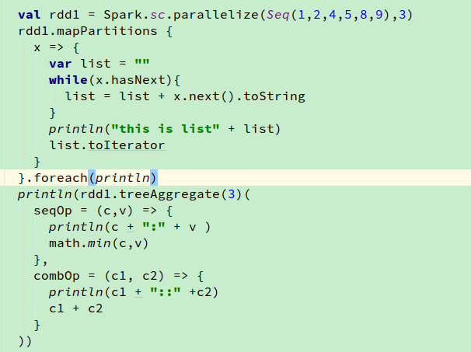

这个代码换成aggregate 将看到 10 现在是 7

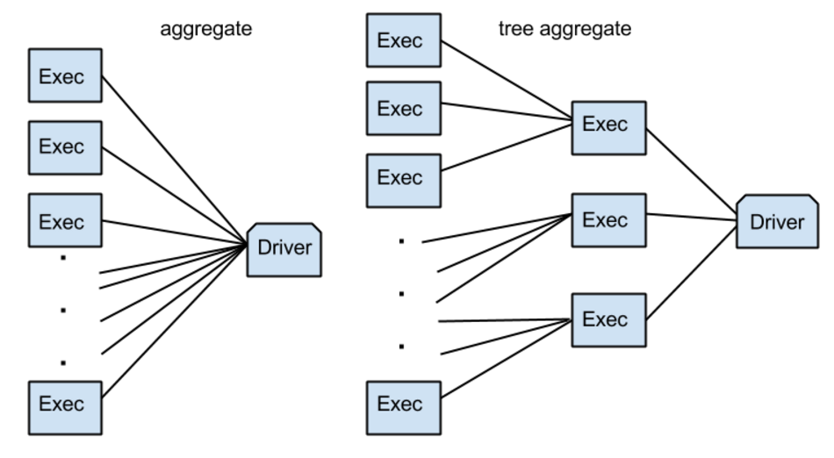

源码分析：

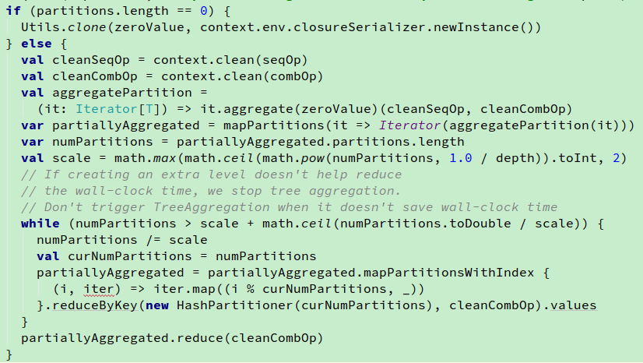

解释：

Depth：树结构的深度

Scale: 树的叉数

可以发现确实是当partitions 个数小于等于5的时候没有shuffle，直接调用了reduce

numPartitions = 5

scale = 2

Math.ceil(numPartitions.toDouble /scale) = 3